# Scratch logo and symbol, meaning, history, PNG

**Scratch Invaders 2**

Register/login at <https://scratch.mit.edu>

*Defend your planet from the invaders.*

1. Download *invader* images from:  
   <https://codeclub67.github.io/images/invader.gif>
2. Create a new sprite by uploading the *invader* images.
3. Rename it as “base” and select the base costume.
4. 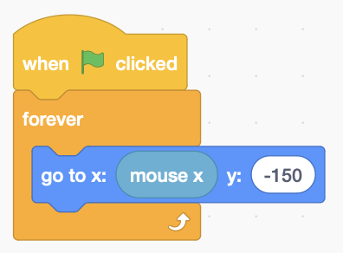Duplicate the base, rename the copy “missile”, and select the missile costume.
5. 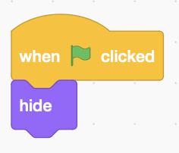Add base code to control it with the mouse:
6. Add missile code (left) so it starts hidden.

*Use the space key to launch a missile.*

1. 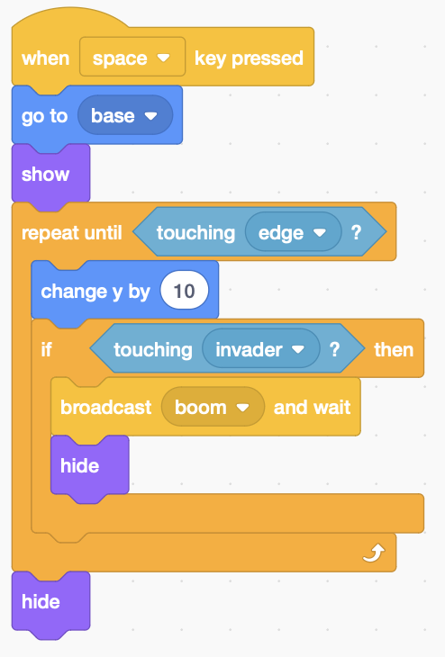Add missile launch code when the space key is pressed. The missile starts at the base and moves up the screen until it **touches** the top edge.
2. If the missile touches an invader it sends a message to be received by the invader sprite.

*If you have more than one row of invaders, add more* ***if*** *blocks for them.*

1. 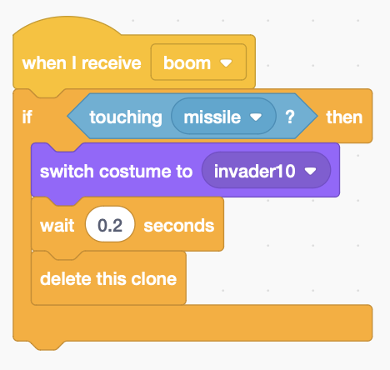The invader responds by blowing itself up. Remember, all sprites receive the message so you have to check which one is **touching** the missile.
2. **Switch** to costume 10, which is a small explosion.
3. 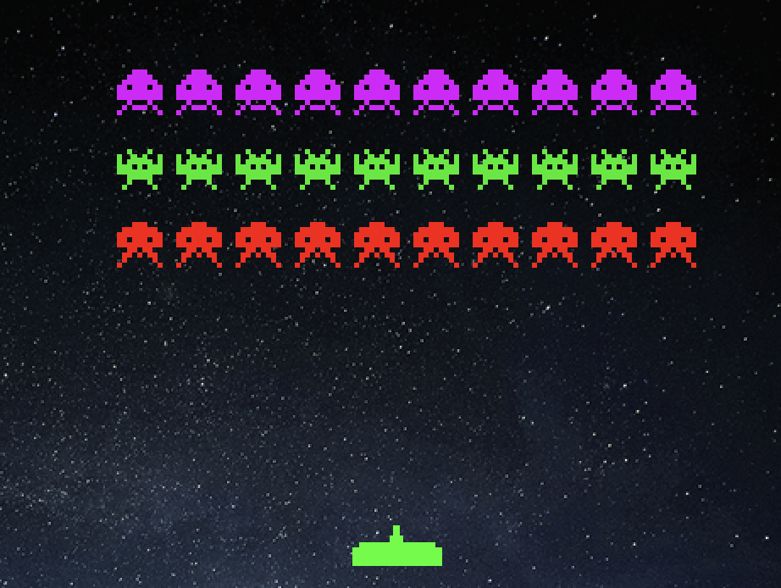After a small **wait**, delete the clone.

*Remember to* ***Save*** *your code.*